**Place/Location**: home

**Task Description:**

To continue the group logo I had received some credits of which were much appreciated. Joaquin asked me if there was a way to make the lightning bolt more diagonal. I liked the idea and so I Implemented it. there and the I liked how it was turning out but I thought it still needed something extra so I decided to use the following effect to be wrap around my final design:

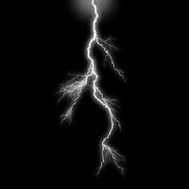

Again using some Photo Shop magic I image to wrap this around our logo. I had to use multiple copies of this image in order to do so. this took a bit of time to make and then we had our logo. I was very confident that everyone would be more then pleased to have it as our logo after all I did dedicate a lot of time on it. So far this would be our logo:

